Colegio San Agustin – Makati  CHEMISTRY 2ND GRADING REVIEWER  SY: 2011 – 2012 | CSA SCIENCE PROMOTES  THE CULTURE OF EXCELLENCE
TOPICS
- Covalent bonds
- Introduction to Lewis Structure
- Formal Charge
- Resonance Structures
- Breakdown of the Octet Rule
Case 1. Odd number of valence electrons
Case 2. Octet deficient molecules
Case 3. Valence shell expansion
- Ionic Bonds
- Polar Covalent Bonds and Polar Molecules
- The Shapes of molecules: VSEPR theory
  - Molecules without lone pairs
  - Molecules with lone pairs
- Molecular Orbital Theory
  - Bonding and antibonding orbitals
  - Homonuclear diatomic molecules
    - Molecules with MO’s originating from s orbitals
    - Molecules with MO’s originating from the s and p orbitals
  - Heteronuclear diatomic Nucleus
- Valence Bond Theory and Hybridization
  - Sigma and pi bonds
  - Hybridization of atomic orbitals
    - sp³ hybridization
    - sp² hybridization
    - sp hybridization

- Covalent Bonding

Chemical bonds form between atoms when the arrangement of the nuclei and electrons of the bonded atoms results in a _____________ (more negative) energy than that for the separate atoms.

A covalent bond is a pair of electrons ______________ (sometimes equally, sometimes not) between two atoms. Covalent bonds form between nonmetals.

H – atom H₂ – molecule

The two H-atoms shown are bound together by the coulombic attraction between the electrons and each nucleus. Since neither atom loses an electron completely, the full IE is not required to form the bond.
In bonding, r = distance between nuclei.

We can plot the energy of the two H-atoms as a function of internuclear distance, r.

0.74 A

- 436
0
H – H distance

Energy (KJ/mol)

Brown, LeMay, Bursten, Chemistry The Central Science, 2000, page 318
no interaction
increased
attraction
balanced attraction
& repulsion
increased
repulsion

Potential Energy Diagram - Attraction vs. Repulsion
(internuclear distance)

Energy of interaction = nuclear-nuclear + electron-nuclear + electron-electron repulsion attraction repulsion

- Introduction to the Lewis Structure

G.N. Lewis (American scientist, 1875-1946). Twenty years prior to the development of quantum mechanics, Lewis recognized an organizing principle in bonding. Namely that:

The key to covalent bonding is electron sharing, such that each atom achieves a ___________ valance shell (noble gas configuration).

OCTET RULE: electrons are distributed in such a way that each element is surrounded by eight electrons, an octet. Each dot in a Lewis structure represents a ______________ e⁻.
F

F

EXCEPTION WITH H: special stability is achieved with ______ electrons.
H

Cl

Each valence e⁻in a molecule can be described as a bonding or a lone-pair electron. For Cl in HCl
_____ bonding electrons
_____ lone-pair electrons or ______ lone pairs

Lewis structures correctly predict electron configurations 90% of the time. Our other option: solve the Schrödinger equation.

PROCEDURE FOR DRAWING LEWIS STRUCTURES

- Draw a skeleton structure. H and F are always terminal atoms. The element with the lowest ionization energy goes in the middle (with some exceptions).
- Count the total number of valence electrons. If there is a negative ion, add the absolute value of total charge to the count of valence electrons; if positive ion, subtract.
- Count the total # of e⁻s needed for each atom to have a full valence shell.
- Subtract the number in step 2 (valence electrons) from the number in step 3(total electrons for full shells). The result is the number of bonding electrons.
- Assign 2 bonding electrons to each bond.
- If bonding electrons remain, make some double or triple bonds. In general, double bonds form only between C, N, O, and S. Triple bonds are usually restricted to C, N, and O.
- If valence electrons remain, assign them as lone pairs, giving octets to allatoms except hydrogen.
- Determine the formal charge.

Lewis structures share the total number of valence electrons between atoms so that each atom achieves a noble gas configuration.

EXAMPLE: Hydrogen cyanide (HCN)

- Draw skeleton structure. H and F are always terminal atoms. The element with the lowest ionization energy goes in the middle (with some exceptions).

H C N

- Count the total # of valence e⁻s. If there is a negative ion, add the absolute value of total charge to count of valence electrons; if a positive ion, subtract.

1 + 4 + 5 = 10 valence electrons

- Calculate the total # of e⁻s needed for each atom to have a full valence shell.

2 + 8 + 8 = 18 electrons to complete the octet Note: Hydrogen is an exception to the octet rule due to its orbital

- Subtract the number in step 2 (valence electrons) from the number in step 3(total electrons for full shells). The result is the number of bonding electrons.

18 electrons – 10 valence electrons = 8 bonding electrons

- Assign 2 bonding electrons to each bond.

H : C : N

- Are there any remaining bonding e⁻s? ___YES________. If bonding electrons remain, include double or triple bonds.

8 bonding electron – 4 bonded electrons = 4 bonding electrons left

H : C ::: N

- Are there any remaining valence electrons? ____YES______. If valence electrons remain, assign as lone pairs, giving octets to all atoms except H.

10 valence electrons – 8 bonding electrons = 2 electrons for lone pairing

H : C ::: N :

- Determine the formal charge. (We’ll learn to do this in Section C of the notes.)

EXAMPLE: Cyanide ion (CN⁻)

- skeletal structure.

- # of valence e⁻s. (Don’t forget the -1 charge!)

- # of e⁻s for each atom to have a full valence shell.

- # of bonding e⁻s.

- Assign 2 bonding electrons per bond.

- remaining bonding electrons? _________

- remaining lone pair e⁻s? _________

- determine formal charge.

EXAMPLE: Thionyl chloride (SOCl₂)

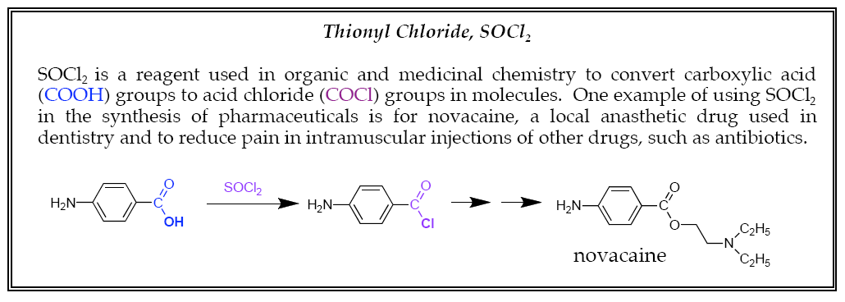

- skeletal structure of SOCl₂.

- # of valence e⁻s.

- # of e⁻s for each atom to have a full valence shell.

- # of bonding e⁻s.

- Assign 2 bonding e⁻s per bond.

- remaining bonding e⁻s? ________

- remaining lone pair e⁻s?

- determine formal charge.

- FORMAL CHARGE (FC)
Formal charge is a measure of the extent to which an atom has gained or lost an _______________ in the process of forming a covalent bond.
To assign formal change, use the formula below.

FC = V – L -(½)S
V ≡ number of _______________ electrons
L ≡ number of _______________ electrons
S ≡ number of _______________ (bonding) electrons

For an electronically-neutral molecule, the sum of the formal charges of the individual atoms must be ___________.

For a molecule with a net charge of -1, the sum of the formal charges of its atoms must be ______.

The sum of individual formal charges must equal the total charge on the molecule!

Let’s go back to two of Lewis structure examples.
EXAMPLE: CN⁻
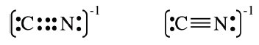
FC on C =V –L-(½)S = _____ -_____ -(½) _____ = _____
FC on N = V –L-(½)S = _____ -_____ -(½) _____ = _____

EXAMPLE: SOCl₂
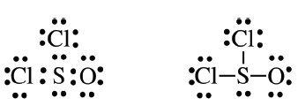

FC on S = _____ -_____-(½) _____ = _____
FC on O = 6 -6 -(½)2 = _____
FC on eachCl = 7 –6-(½) 2 = _____

In general, more electronegative atoms should hold the negative charge.

Note: FORMAL CHARGE ≠ OXIDATION NUMBER

Formal charge is very helpful in deciding between possible Lewis structures.
Structures with lower absolute values of FC are the _________ stable (lower energy) structures.

For example, consider the three possible structures for the thiocyanate ion, CSN⁻. The ionization energies in kJ/mol for C, S, and N are IE_{C} = 1090, IE_{S} 1000, IE_{N} = 1400.

Based on IE alone, we would predict _____ to be the central atom.

structure A structure B structure C

 | FC_{N} = ________________ |  | FC_{N} = 5 – 4 -2 = _______ |  | FC_{N} = 5 – 0 -4 = _______
FC_{C}=_______________ |  | FC_{C} = 4 – 4 -2 = _______ |  | FC_{C} = 4 – 4 -2 = _______
FC_{S} =_______________ |  | FC_{S} = 6 – 0 -4 = _______ |  | FC_{S} = 6 – 4 -2 = _______
The most stable structures is_______.

If two valid Lewis structures have the same absolute value of formal charges, the more stable structure is the one with a negative charge on the more electronegative atom.

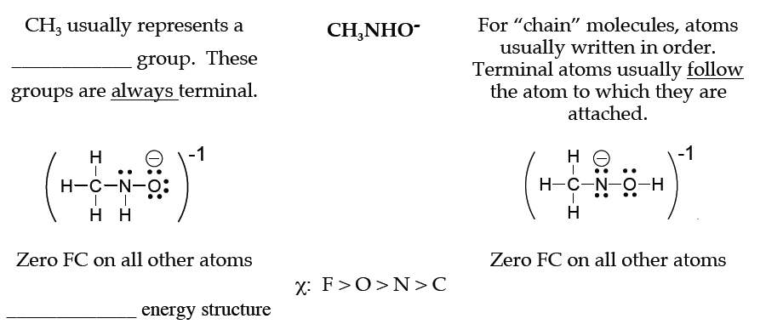

- Resonance Structures

For certain molecules, more than one Lewis structure is needed to correctly describethe valence electron structure of the molecule.

For example, consider the Lewis structure(s!) of ozone, O₃.
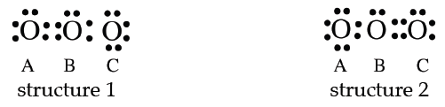
1) skeletal structure
2) valence e–s: 3(6) = ______
3) full shell e–s: 3(8) = ______
4) bonding e–s: ______ – ______ = ______
5) assign bonding e–s
6) remaining bonding e–s: 2
7) remaining valence e–s (assigned as lone pairs): 12
8) formal charges:
Structure 1 Structure 2 FC_{OA} = ______ FC_{OA} = ______ FC_{OB} = ______ FC_{OB} = ______ FC_{OC} = ______ FC_{OC} = ______

We might expect one short O=O bond and one long O-O bond, but experimental evidence demonstrates that the two bonds are __________________.

Thus, the two structures are equivalent. A better model is to blend the structures asdenoted with the brackets and arrows below, a resonance hybrid.
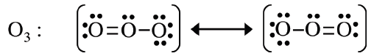

Electrons in resonance structures are ________________. Electron pairs are shared over several atoms, not just two.

Resonance structures are two (or more) structures with the same arrangement of ____________, but a different arrangement of ________________.

- BREAKDOWN OF THE OCTET RULE

Case 1. Odd number of valence electrons

For molecules with an odd number of valence electrons, it is not possible for each atom in the molecule to have an octet, since the octet rule works by ____________ e⁻s.

Example: CH3
2) 3(1) + 4 = ______ valence electrons
3(2) + 8 = ______ electrons needed for octet
4) 14 – 7 = ________ bonding electrons

Radical species: molecule with an ________________ electron.

Radicals are usually very reactive. The reactivity of radical species leads to interesting (and sometimes harmful) biological activity.

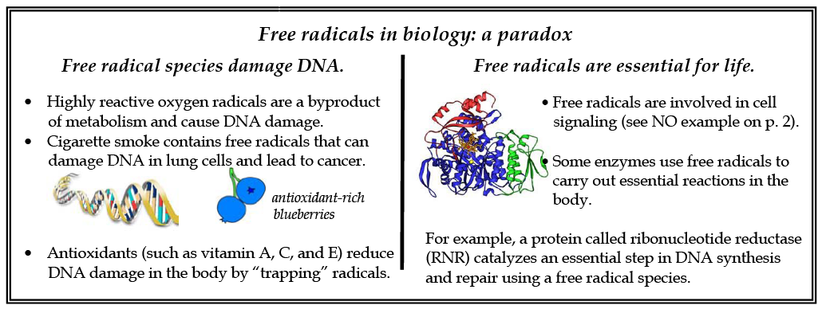

Some radicals are more stable. For example, NO

NO N O

1) Draw skeletal structure
2) 5 + 6 = 11 valence electrons
3) 8 + 8 = 16 electrons needed for octet
4) 16 – 11 = ______ bonding electrons

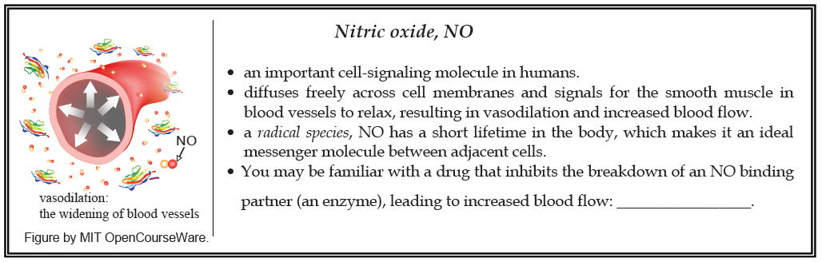

Now let’s think about molecular oxygen, O2. What we expect: O O
2) | _______________ valence electrons
3) | _______________ electrons needed for octet
4) | _______________ bonding electrons
5) | Add two electrons per bond.
6) | 2 bonding electrons remaining. Make double bond.
7) | _______________ valence electrons – make lone pairs

Lewis method seems to work here, but in reality O₂ is a ________________!

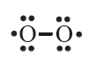

We need molecular orbital (MO) theory (Section J).

Case 2. Octet deficient molecules
Some molecules are stable with an incomplete octet. Group 13 elements ____ and _____ have this property.

Consider BF3
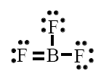
First, let’s write the Lewis structure that achieves octets on every atom.
2) 3 + 3(7) = ______ valence electrons
3) 8 + 3(8) = ______ electrons needed for octet
4) 32 – 24 = ________ bonding e⁻s
5) assign two electrons per bond.
6) 8 – 6 = 2 extra bonding electrons
7) 24 – 8 = 16 lone pair electrons 8) calculate formal charges:
FC_{B} = 3 – 0 – (½)(8) = -1
FC_{FDB} = 7 – ____ – (½)(____) = _______
FC_{F} = 7 – ____ – (½)(____) = _______
But experiments suggest that all three B-F bonds have the same length, that of a ______________ bond.

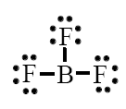
FCB = 3 – 0 – (½)(6) = 0
FCF = 7 – 6 – (½)(2) = 0

The formal charges are more favorable for this structure.

Case 3. Valence shell expansion

Elements with n = or > 3 have empty ____ -orbitals, which means more than eight electrons can fit around the central atom.

Expanded valence shells are more common when the central atom is ______ and is bonded to small, highly electronegative atoms such as O, F, and Cl.

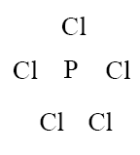
Consider PCl5
2) 5 + 5(7) = ______ valence electrons
3) 8 + 5(8) = ______ electrons needed for octet
4) 48 – 40 = ______ bonding e⁻s

To make five P-Cl bonds, need ______ shared electrons. So 40 – 10 = 30 lone-pair electrons.

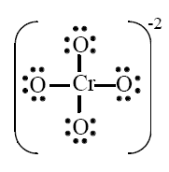
Consider CrO₄⁻²
2) 6 + 4(6) + _____ = ______ valence electrons
3) 8 + 4(8) = ______ electrons needed for octet
4) 40 – 32 = ______ bonding e⁻s
7) 32 – 8 = 24 lone-pair electrons.
8) calculate formal charges:
FCCr = 6 – 0 – (½)(8) = +2
FCO = 6 – 6 – (½)(2) = -1
Total charge = 2 + 4(-1) = -2

But experimentally, Cr-O bond length and strength are between that of a single and double bond!
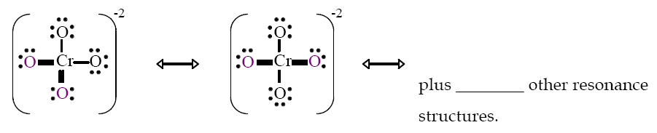
FC_{Cr} = 6 – 0 – (½)12 = 0
FC_{ODB} = 6 – 4 – (½)4 = 0
FC_{O} = 6 – 6 – (½)2 = -1

- IONIC BONDS
Ionic bonds involve the complete _____________ of (one or more) electrons from one atom to another with a bond resulting from the electrostatic attraction between the cation and anion.

Consider the formation of NaCl from the neutral atoms, Na and Cl.

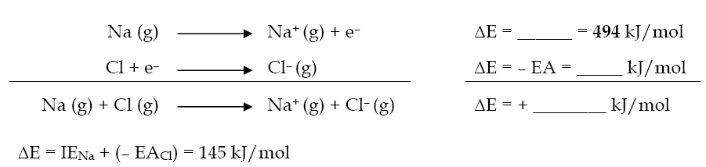

Problem: Na (g) + Cl (g) ⇒ Na⁺ (g) + Cl– (g) has a positive ΔE. It ___________ energy.
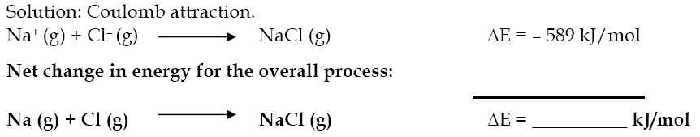

The mutual attraction between the oppositely-charged ions releases energy. The net energy change for the formation of NaCl is a decrease in energy.

- POLAR COVALENT BONDS
Perfectly-ionic and perfectly-covalent bonds are the two extremes of bonding. In reality, most bonds fall somewhere in the middle.

A polar covalent bond is an ____________ sharing of electrons between two atoms with different electronegativities (χ).
Consider H-Cl versus H-H (Pauling electronegativity values are given):
H – Cl χH = 2.2 χCl = 3.2
H^{δ+}– Cl^{δ–}
where δ is fraction of a full charge (e) that is asymmetrically distributed.
H – H H2 is a “perfectly” covalent bond, δ = 0.

Dipole moment
Asymmetric charge distribution results in an electric dipole, two unlike charges separated by a finite distance.

We can quantify charge separation by defining a dipole moment, μ.

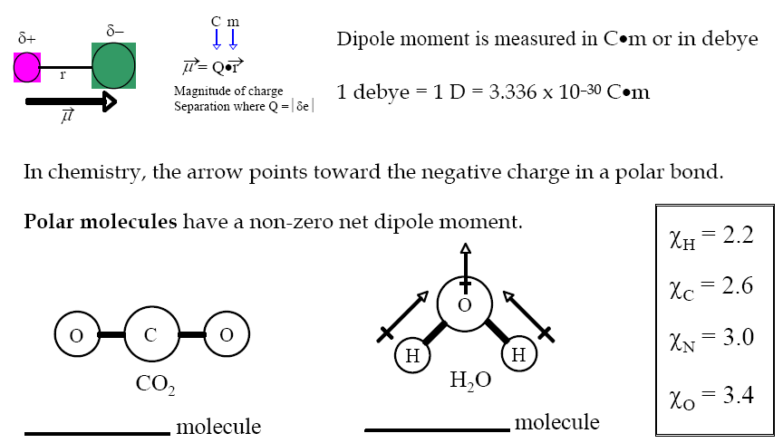

In large organic molecules and in biomolecules, such as proteins, we often consider the number of polar groups within the molecule.

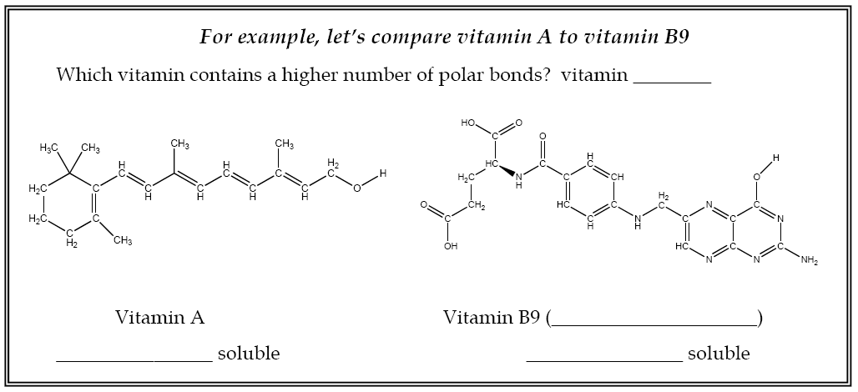

- THE SHAPES OF MOLECULES: VALENCE SHELL ELECTRON PAIR REPULSION (VSEPR) THEORY
The shape (_______________ ) of molecules influences physical and chemical properties, including melting point, boiling point, and reactivity.

Shape is particularly important in biological systems where, for example, a molecule must fit precisely into the active site of an enzyme.

VSEPR Theory can be used to predict molecular geometry with high accuracy. The theory is based on Lewis structure and the principles that
- Valence electron pairs ___________ each other.
- The geometry around the central atom will be such as to minimize the electron repulsion.

VSEPR nomenclature:
A = ______________ atom

X = ______________ atom
E = lone pair
General guidelines for the VSEPR model:
______________ number (SN) is used to predict geometries.
SN = (# of atoms bonded to central atom) + (# of lone pairs on central atom)

Note: When considering electron-pair repulsion, double bonds and triple bonds can be treated like single bonds. This approximation is valid for qualitative purposes.

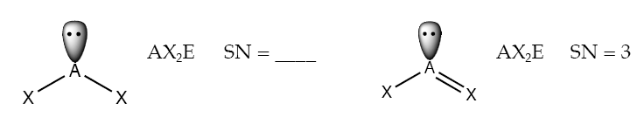

This means the number of ______________ bonded to the central atom is important, not the BONDS to central atom.
- If a molecule has two or more resonance structures, the VSEPR model can be applied to any one of them.
- If there is more than 1 central atom in a molecule, consider the bonding about each atom independently.

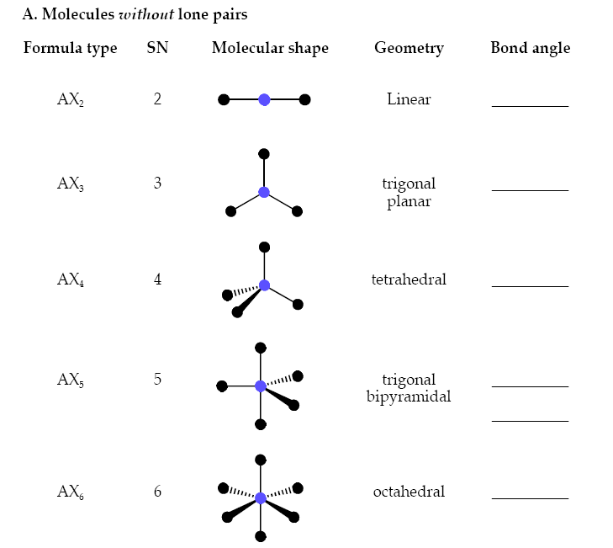
Note: Bonds into the paper are dashed, and bonds out of the paper are thick andtriangular.

Examples of molecules without lone pairs:
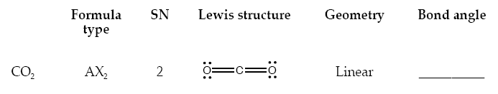

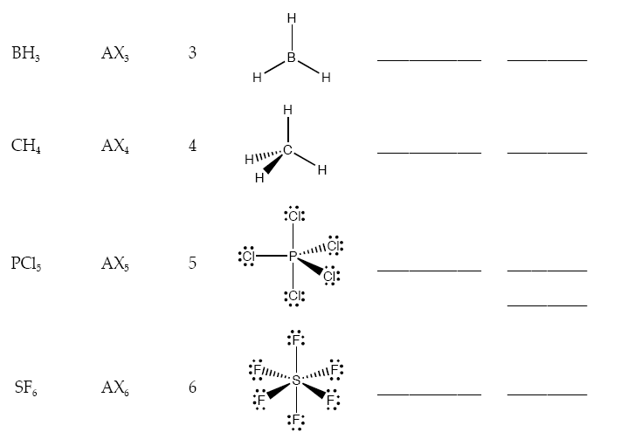

Molecules with lone pairs
When lone pairs are involved, additional details must be considered.

Attractive forces exerted by the nuclei of the two bonded atoms hold electrons in a bond. These electrons have less "spatial distribution" than lone pairs, meaning
- electrons in bonds take up ___________ space.
- lone-pair e⁻s take up more space, and therefore experience ________ repulsion.

Thus, according to VSEPR, the repulsive forces decrease in the following order:

lone-pair/lone-pair > lone-pair/bonding-pair > bonding-pair/bonding-pair
repulsion repulsion repulsion

Rationalization of shapes based on VSEPR theory

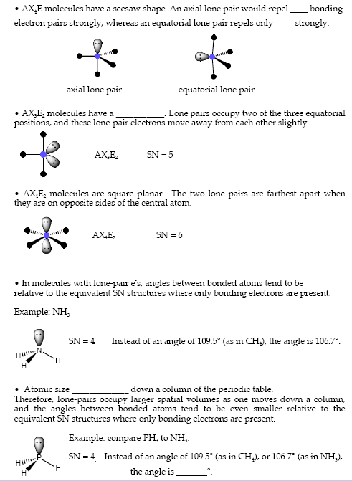
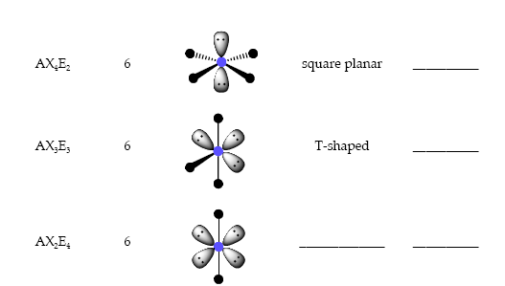
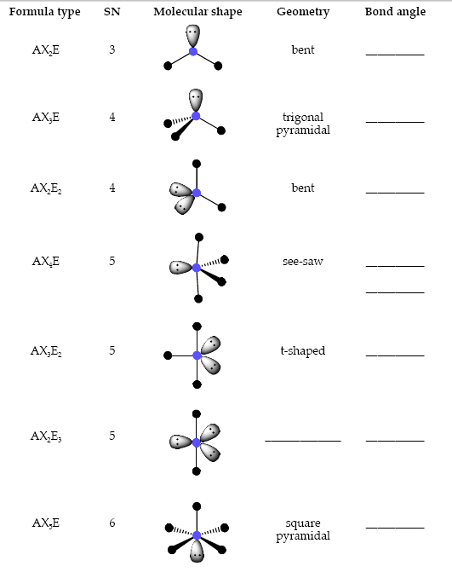
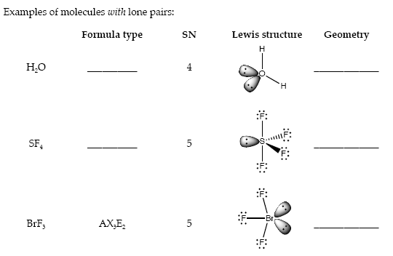
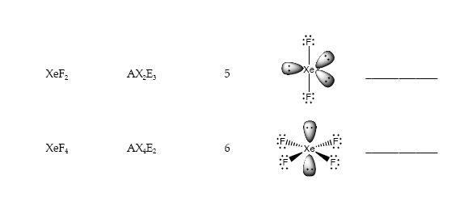

The ideas of VSEPR make possible many predictions (or rationalizations) of molecular geometries about a central atom. There are very few incorrect predictions.

However, VSEPR provides no information about energies of bonds or about how multiple bonds affect structure.

- MOLECULAR ORBITAL (MO) THEORY
In MO theory, valence electrons are _________________ over the entire molecule, not confined to individual atoms or bonds, as in Lewis and valence-bond models.

- BONDING AND ANTIBONDING ORBITALS
Molecular orbitals (____________________) of diatomic molecules arise from adding together (superimposing) atomic orbitals:

Linear combination of atomic orbitals (LCAO) to create a molecular orbital.

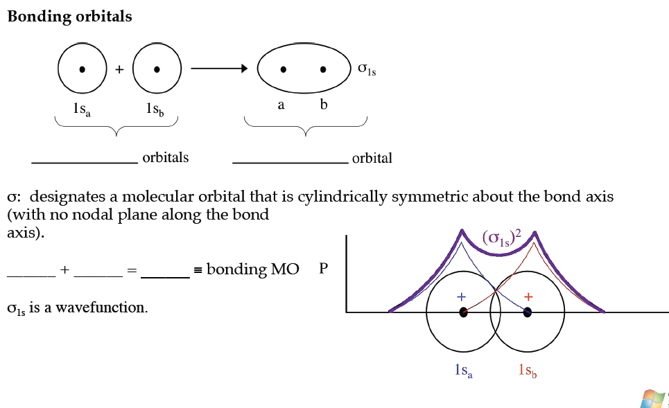

As with atomic wavefunctions, the physically significant quantity for molecular wavefunctions is probability density (P).
P ∝ (______)² = (_____ + _____)² = (1s_{a})² + (1s_{b})² + 2(1s_{a})(1s_{b})
interference term
The cross-term represents ____________ interference between the two wavefunctions.
The result is a ______________ orbital: higher probability density between the nuclei.

Energy of interaction for bonding orbitals. The energy _______________ compared to the atomic orbitals!

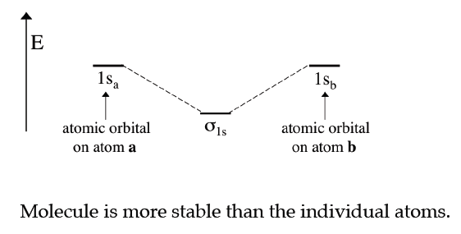

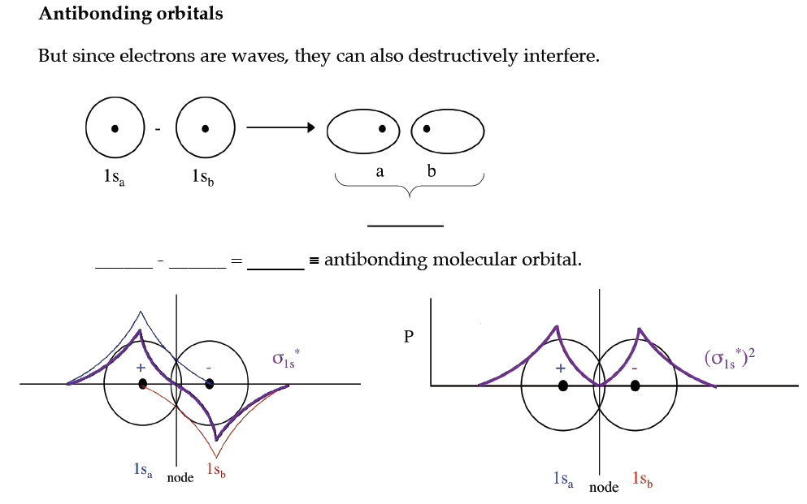
Probability density, P ∝ (______)² = (_____ _____)² = (1s_{a})² + (1s_{b})² - 2(1s_{a})(1s_{b})
interference term

The cross-term represents ____________ interference between the two wavefunctions. The result is lower probability density between the nuclei, an antibonding orbital.

Energy of interaction for antibonding orbitals. The energy ______________ compared to the atomic orbitals!

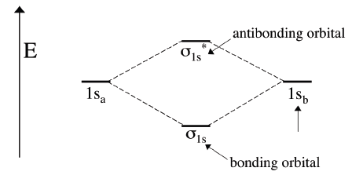

σ1s* is an ___________________ orbital.

  - Less electron density accumulates between nuclei, exposing nuclei to greater repulsions.
  - Creates an effect exactly opposite to a bond. Antibonding is ____ nonbonding.
  - An antibonding orbital is raised in energy by approximately the same amount that the bonding orbital is lowered in energy.

- HOMONUCLEAR DIATOMIC MOLECULES

- Molecules with MO’s originating from s orbitals

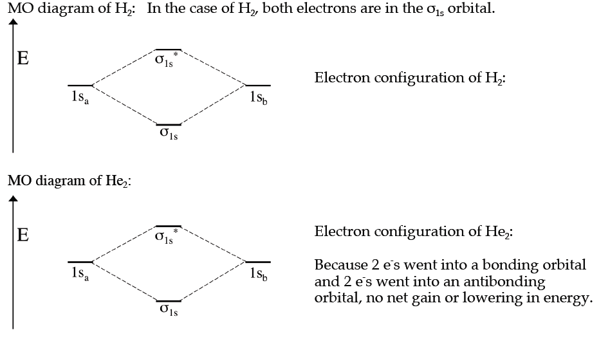

MO theory predicts He₂ _____________ exist because no net gain in E.

BOND ORDER = ½ (# of bonding electrons -# of antibonding electrons)

He₂: (σ_{1s})²(σ_{1s}*)²
bond order = _____________________________ ____________ bond
H₂: (σ_{1s})²
bond order =_____________________________ ___________ bond

Reality: He₂ does exist. ‘Discovered’ in 1993. Weakest chemical bond known.
ΔE_{d} = 0.01 kJ/mol for He₂
ΔE_{d} = 432 kJ/mol for H₂

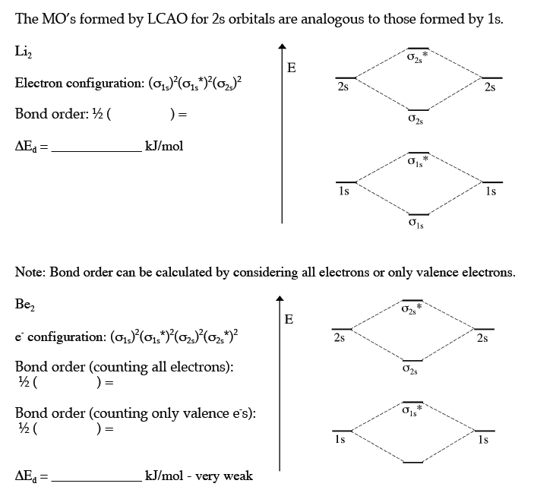

- Molecules with MO’s originating from s and p orbitals

Bonding MO's formed by LCAO of 2p_{x} and 2p_{y}
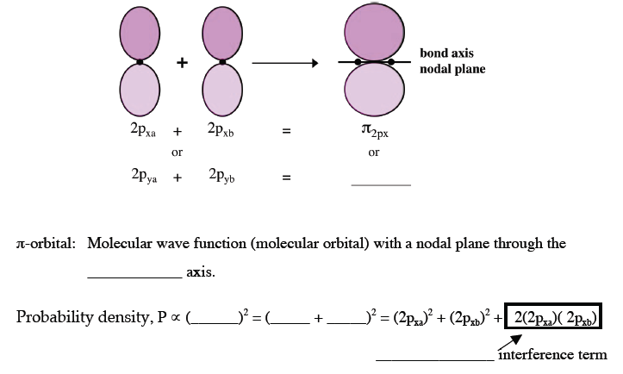
Antibonding MO’s formed by LCAO of 2p_{x} and 2p_{y}

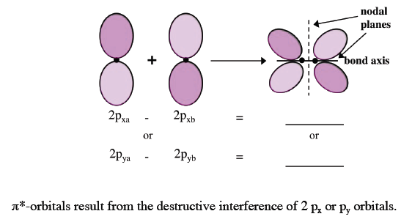

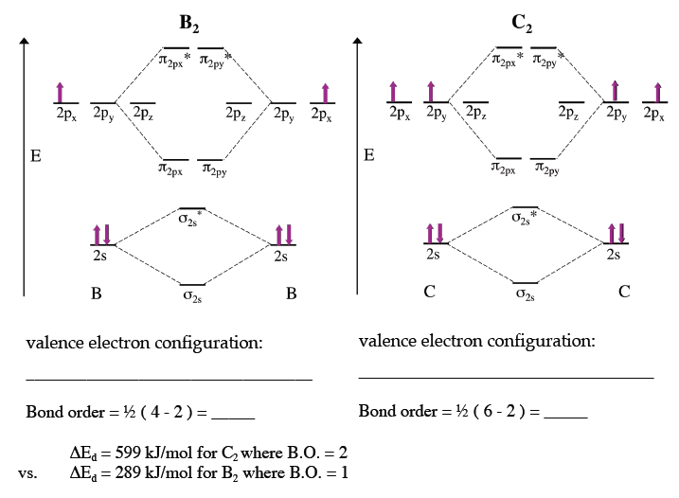

Bonding MO's formed by LCAO of 2p_{z}
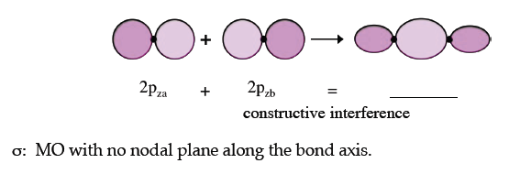

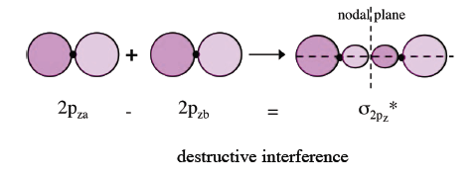
Antibonding MO's formed by LCAO of 2p_{z}

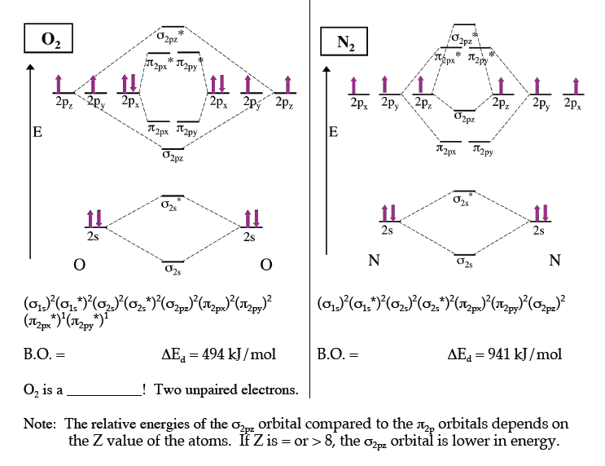

- VALENCE BOND THEORY AND HYBRIDIZATION
In valence bond theory, bonds result from the pairing of unpaired electrons in atomic orbitals.
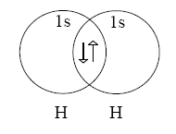
- Sigma and pi bonds
σ (sigma) bond: cylindrically symmetric with ____ nodal plane across the bond axis.
π (pi) bond: a bond with e⁻ density in two lobes, one on each side of the bond axis.
A pi bond has a _______________ nodal plane along the bond axis.

We can describe multiple bonds according to valence-bond theory.
- single bond: ____________________
- double bond: one σ-bond plus one ____________________
- triple bond: one σ-bond plus ___________ π-bonds
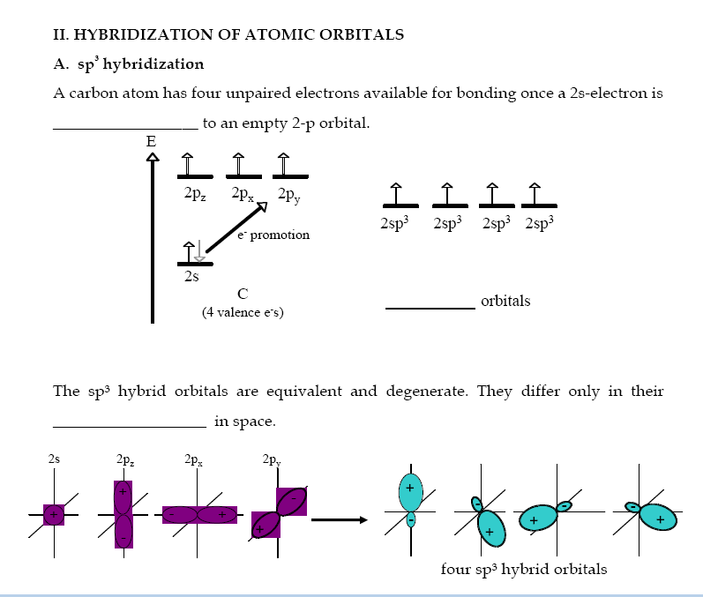

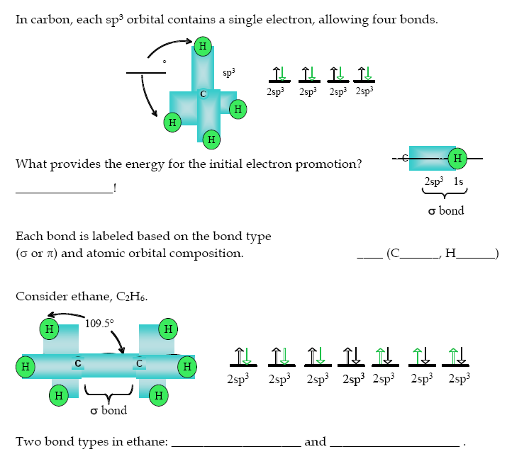

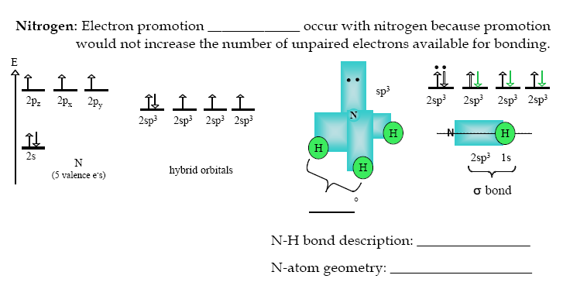

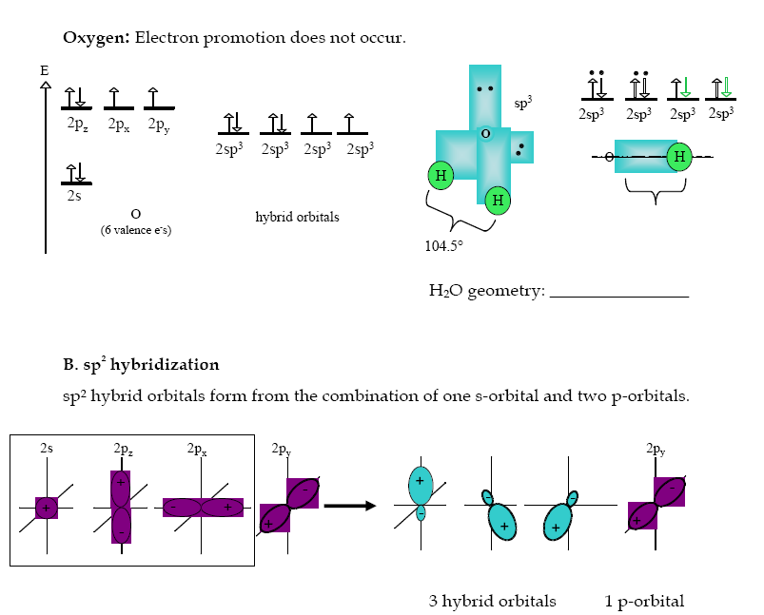

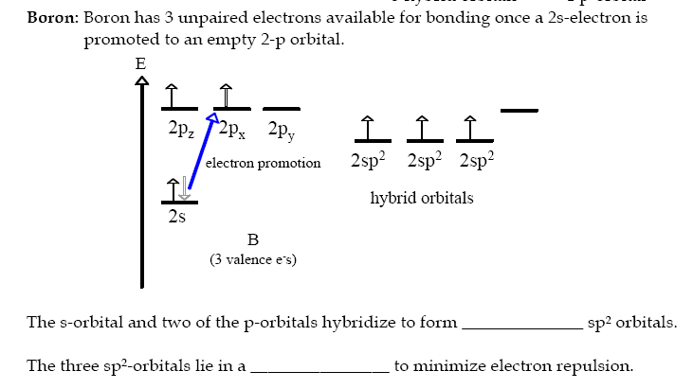

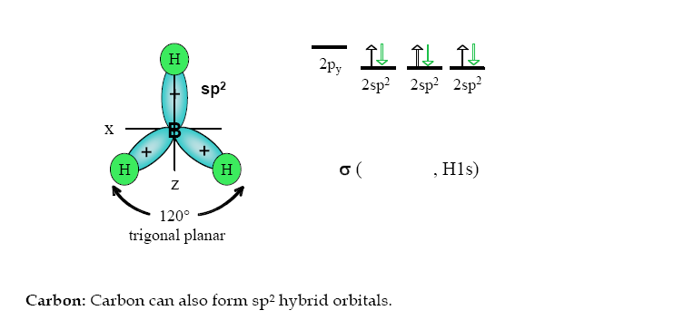

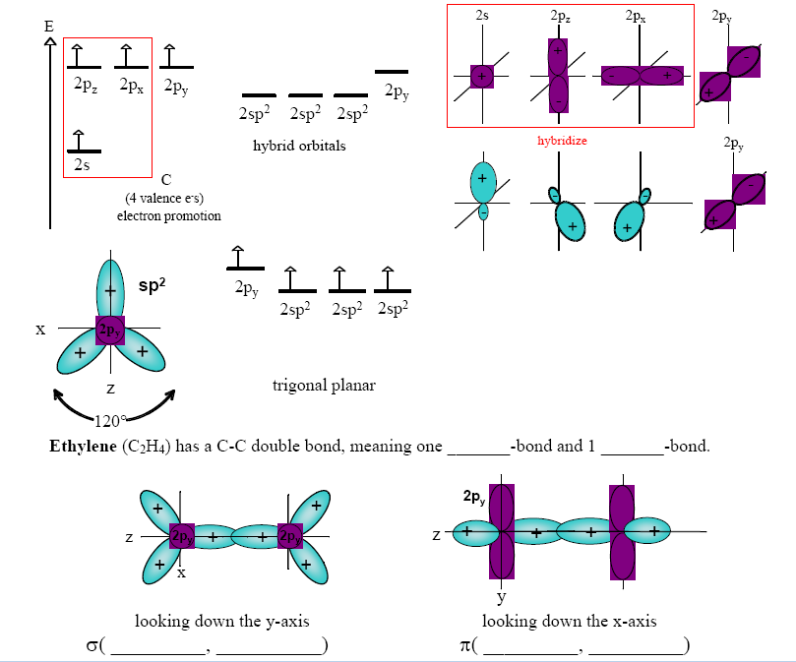
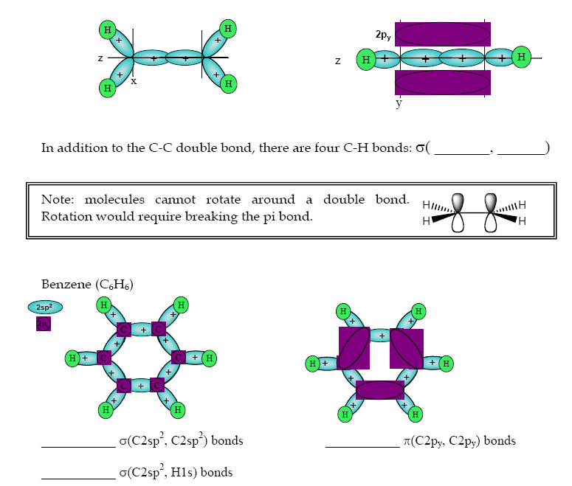

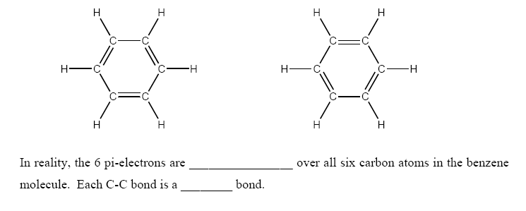

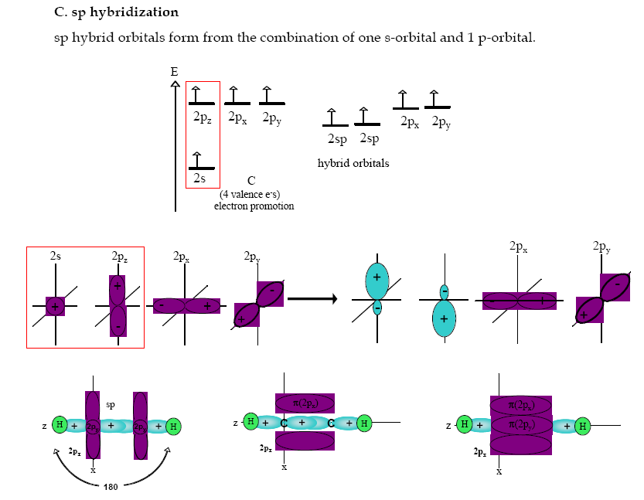
σ( ______, _______ ) π( ______, _______ ) π( ______, _______ )

