Colegio San Agustin – Makati  CHEMISTRY ALTERNATIVE ASSESSMENT  SY: 2011 – 2012 | CSA SCIENCE PROMOTES  THE CULTURE OF EXCELLENCE

INTRODUCTION

The Chemistry Alternative Assessment is patterned on the Future Cities India 2020 competition. This project opens the minds of students on the different undeveloped areas in the Philippines and unused or misused resources around the country. The project encourages the students to develop, design and integrate the functionality of their ideas while fostering an interest in mathematics, science, engineering, architecture and facility planning through a hands-on, real-world application.

Each section will be given a land area with its geography, and it will be divided to each laboratory groups, which will develop a specific area. Each group will research on the natural resources, security conditions and demography. The information gathered will be used in planning the model.

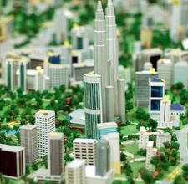
Procedure

Build a model city as an independent project or a group exercise to study urban planning or architectural design. Determine if the city will be a replica of an existing city or if a new design is allowed. Utilize light materials such as cardboard boxes and plastic containers when possible to reduce the weight of the final model. Follow this simple version of building a city to reduce construction time and expense.

- If the model is a replica of an existing city, review maps and photos of the area to identify streets, buildings, parks, water and any other items that will be represented on the model. If the model is a new design, create a diagram with all of the items that will need to be built.

- Determine the scale that will be used. A 50 scale indicates 1 inch equals 50 feet, a 30 scale is 1 inch equals 30 feet. The smaller the scale, the larger the final model will be. Draw out the location of the roads, buildings, water features and parks on the plywood using the scale chosen. Make changes in scale as necessary to ensure all required features are included.

- Design and build specific buildings. Use premade boxes cut to the correct size, scrap boxes, or a combination of both. Try shoeboxes, cereal boxes, milk cartons and noodle boxes for variety in shapes and sizes. Paint each box with a base coat on the exterior and then add details such as windows and doors with black paint. The base coat should reflect the desired color of the building. Gray can be used for steel buildings, red for brick. Set the painted items aside to dry completely. If a building needs an unusual shape, use modeling foam to add the shape to a box.

- Paint primer onto the plywood before applying paint. Paint roads with black paint. Paint water features blue. Paint parks with green. Allow the paint to dry completely.

- Glue buildings to the plywood. Add details such as fences, lights, trees, cars and people as desired.

Read more: How to Build a City for School Projects | eHow.com http://www.ehow.com/how_6154302_build-city-school-projects.html#ixzz1a9WOJo8F

Watch a video on how to make a paper building: http://spayneville.blogspot.com/

More resources at www.youtube.com

Kalayaan, Palawan, Philippines
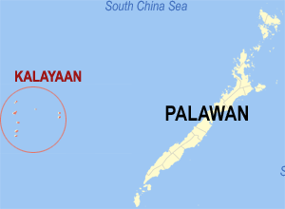
From Wikipedia, the free encyclopedia
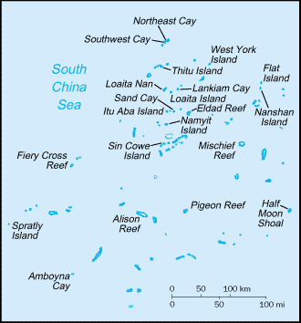
Kalayaan is a 5th class municipality in the province of Palawan, Philippines. According to the 2000 census, it has a population of 223 people in 12 households.
Kalayaan is composed of only one barangay, Pag-Asa. This island has a 1.3 km airstrip that is used both by the military and civilians. It has a regulated civilian population of about 350, most of whom are fishermen. This civilian population is the result of Philippine government initial efforts to put civilians in the Kalayaan. Once a month, a Philippine Navy Ship goes to this island to drop supplies of goods. This island has a water-filtering plant, power generators, weather stations and a communication tower which is built by the Philippine-based SMART Telecommunications.
The municipal government of Kalayaan is making new projects to promote tourism for the island. Also, they had been successful in convincing many Filipino businessmen to invest in Kalayaan.

GEOGRAPHY

The Municipality of Kalayaan is located in the western section of the Province of Palawan. It is composed of seven (7) islets and one (1) reef with aggregate land area of approximately 79 hectares. They are: a) Pag-asa, 32.7 has.; b) Likas, 18.6 has.; c) Parola, 12.7 has.; d) Lawak, 7.9 has.; e) Kota, 6.45 has.; f) Patag, 0.57 ha.; g) Panata, 0.44 ha.; h) Ayungin Reef, 0 ha; and I) Rizal Reef, 0 ha.
Pag-asa Island (Thitu Island) has the biggest area, which is 37.2 hectares. The airstrip in the island has an area of 5.6 hectares, running a length of approximately 1,260 meters
Next in terms of land area is Likas Island (West York Is). This island is located 47 miles northeast of Pag-asa and has an area of 18.6 hectares whose outcrops are visible on the southern and eastern portion of the island during low tides. This island is considered a sanctuary for giant sea turtles (pawikan) that lay their eggs on the island all year round.
The high salinity of the ground water in the island retards the growth of introduced trees like coconuts, ipil-ipil, and other types. Only those endemic to the area that are mostly beach type of plants thrive and survive the hot and humid condition especially during the dry season.
Smaller than Likas Island is the Parola Island (Northeast Cay), located 28 miles northwest of Pag-asa Island. Parola has a land area of approximately 12.7 hectares and is closer to the Vietnamese occupied Pugad island than to Pag-asa Island. Some of its outcrops are visible on its western side. It has high salinity groundwater and vegetation limited to beach type of plants. The corals around the island were mostly destroyed by rampant use of dynamite fishing and cyanide method employed by foreign fishing boats in the past.
Kota Island (Loita Is) has a land area of 6.45 hectares and located 22 miles southeast of Pag-asa. It fringes the Laoita bank and reef. Its calcarenite outcrop is visible along its western side at low tide. The present shape of the island indicates sand buildup along its eastern side. The anchor-shaped side will eventually connect with the northern portion as the sand buildup continues thereby creating another mini-lagoon in the process.
The presence of migrating sea birds adds to the high phosphorus contents of the sand found in the island. Occasionally, giant sea turtles are reported to be laying their eggs in the island.
Panata Island (Lankiam Cay) is located 8 miles northeast of Kota Island. It has a surface area of 4,400 sq. meters (0.44 hectare). A few years ago this island has a surface area of more than 5 hectares but strong waves brought by a strong typhoon washed out the sandy surface (beach) of the island leaving behind today the calcarenite foundation that can be seen at low tide.
The Lawak Island (Nanshan Is) has a total land area of 7.93 hectares and located 98.0 miles east of Pag-asa. This island is the bird sanctuary of Kalayaan. Its surroundings are highly phosphatized that superphosphate materials can be mined out on a small-scale basis.
Near the fringes of the breakwaters (approx. 2 miles from the island), intact hard coral reefs were observed to retain their natural environment and beautiful tropical fishes were seen colonizing these coral beds of varying colors.
About 6 miles southwest of Lawak Island is Patag Island (Flat Is). It has a surface area of 5,740 sq. meters (0.574 hectare). Patag Island is an example of a cay. It changes its shape seasonally. The sand build up will depend largely on the direction of prevailing wind and waves. Presently, it takes the shape of an elongated one, three years ago it had a shape like that of a crescent moon, and years back it formed the shape of a letter “S”.
Like Panata Island, it is also barren of any vegetation. No underground water source is found in the island. Presently, this island serves only as a military observation post in Kalayaan.
Rizal (Commodore) Reef
Located nearest to Balabac. It is a typical reef lying underwater and is now being manned by a military contingent based and established in the area.
TOPOGRAPHY
The islets that comprise the Municipality are generally flat. The highest ground elevation is approximately two (2) meters above sea level.

Basilan, Philippines
From Wikipedia, the free encyclopedia

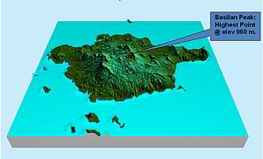
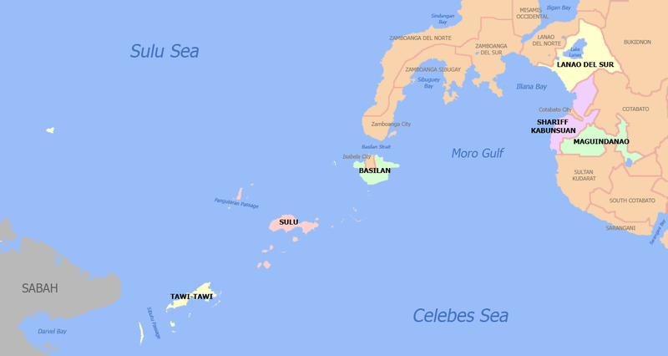

LAND

The province of Basilan has an aggregate historical jurisdiction of 135,892 hectares (335,800 acres), with mainland Basilan encompassing an area of 124,892 hectares (308,610 acres). The province encompasses all of Basilan Island (including Isabela City, which forms part of the province, although it is excluded from the Autonomous Region) and offshore islands, together with the Pilas island group (now Hadji Muhtamad Municipality) west of the island, and the Bubuan and Tapiantana island group (now Tabuan-Lasa Municipality) in the south. These are listed among the Philippine islands with a moderate risk of getting hit by tsunamis.

GEOGRAPHY

Basilan is located between latitudes 6°15' and 7°00', and longitudes 121°15' and 122°30'. The island is bordered by the Basilan Strait to the north, the Sulu Sea to the northwest and west, the Moro Gulf to the northeast, and the Celebes Sea to the south, southeast and east. It is one of the 7,107 islands that make up the Philippine archipelago.

Basilan Island is the largest and northernmost island of the Sulu Archipelago between the Philippine islands of Mindanao and Borneo which includes about 400 islands. Basilan Strait, about 17 nautical miles (31 km) at its narrowest point, separates Basilan Island from the mainland of Mindanao and the port city of Zamboanga. The terrain of the island is simple, with several undulating slopes concentrated around Isabela City along the coastal areas and hilly towards the interior. Urban areas are usually 2.5 metres (8 ft 2 in) above sea level and gently sloping to 300 metres (980 ft) toward the hinterlands. The stand of timber and forest vegetation is more or less evenly distributed throughout.
Basilan National Park is located at the eastern portion of the remaining public forest between the city of Isabela and the municipalities of Lamitan, Tipo-Tipo and Sumisip. The park has an elevation of 971 metres (3,186 ft) above sea level, and the tallest peak, Puno Mahaji or Basilan Peak, dominates the park's landscape.

Culion, Palawan
From Wikipedia, the free encyclopedia

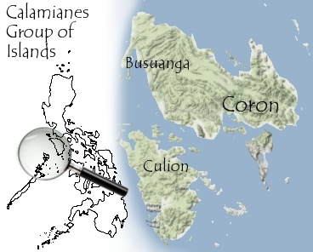

Culion is a 4th class municipality in the province of Palawan, Philippines,[1] consisting of Culion Island primarily and 41 minor surrounding islands. According to the 2006 census, it has a population of 18,000 people in 3,082 households. Culion is part of the Calamian group of islands. It was a former leprosarium under the American commonwealth of the Philippines.[2]

DESCRIPTION

Culion is an island situated at the northernmost part of Palawan. It belongs to the islands in Northern Palawan called Calamianes that includes the municipalities of Busuanga, Coron, and Linapacan. During the Spanish Period, these were known as Las Islas de Calamianes, Provincia de España. It has a total land area of 415 square kilometres (160 sq mi) which includes the 41 surrounding islands and measures a total of 1,191.39 square kilometres (460.00 sq mi) including its territorial water. It is bounded on the north by Busuanga Island, on the east by the Coron Reef, on the south by Linapacan Island, and on the west by the South China Sea.
The Culion sea is teeming with a total of 201 fish species including commercially important fish like Lapu-lapu (Groupers), Kanuping (Sweetlip Emperor), Maya-Maya (Snapper), Tanguige (Spanish Mackerel), Dalagang Bukid (Blue and Gold Fusiliers) and Bisugo (Breams). Squid, cuttlefish, shrimps, crabs, shellfish and sea cucumber or trepang are plentiful.
Three ecosystems sustain the rich marine life of Culion: mangroves, seagrass, and corals. 17 mangrove species cover the coastline of Culion. 9 seagrass species and 47 coral genera representing 60% of the total genera found in the Philippines are found in Culion.

